**Shashwat Tripathi**

**D10A 58**

**BATCH: C**

**PYTHON LAB**

**Exp No: 2**

**AIM:** Write python programs to understand

a) Different List and Tuple operations using Built-in functions

b) Built-in Set and String functions

c) Basic Array operations on 1-D and Multidimensional arrays using Numpy

d) Implementing User defined and Anonymous Functions

**A) LIST, TUPLES, DICTIONARY**

**LIST:**

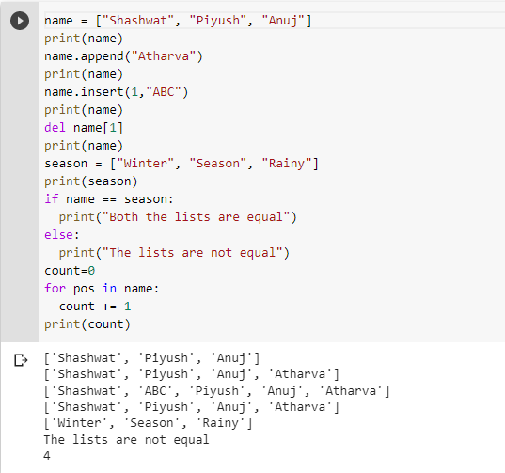

**TUPLE**

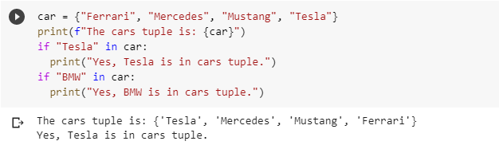

**DICTIONARY**

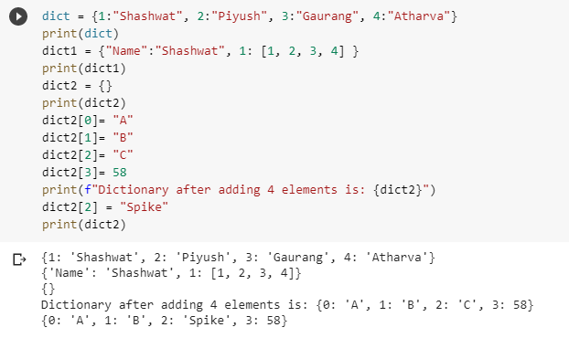

**B) BUILT-IN SET AND STRING FUNCTIONS**

**SETS:-**

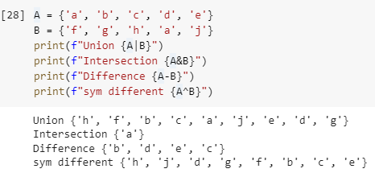

**STRING FUNCTIONS:-**

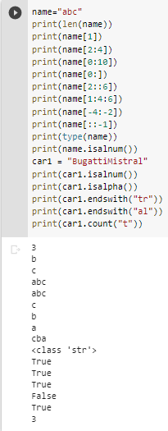

**C) BASIC ARRAY OPERATIONS ON 1-D AND MULTIDIMENSIONAL ARRAYS USING NUMPY**

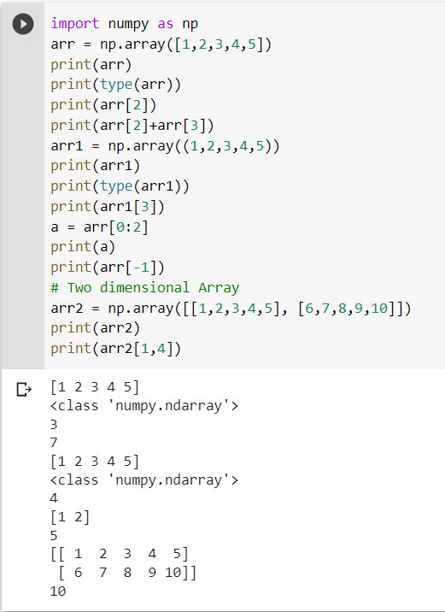

**D) IMPLEMENTING USER DEFINED AND ANONYMOUS FUNCTIONS**

